**Matrices**

**LAB # 02**



**Spring 2021**

**CSE301L-Signal $ System**

Submitted by: **Ashfaq Ahmad**

Registration No: **19PWCSE1795**

Class Section: **B**

“On my honor, as student of University of Engineering and Technology, I have neither given nor received unauthorized assistance on this academic work.”

Student Signature: ______________

Submitted to:

**Engr Durr-e-Nayab**

April 28, 2021

**Department of Computer Systems Engineering**

**University of Engineering and Technology, Peshawar**

**OBJECTIVES OF THE LAB**

‐‐‐‐‐‐‐‐‐‐‐‐‐‐‐‐‐‐‐‐‐‐‐‐‐‐‐‐‐‐‐‐‐‐‐‐‐‐‐‐‐‐‐‐‐‐‐‐‐‐‐‐‐‐‐‐‐‐‐‐‐‐‐‐‐‐‐‐‐‐‐‐‐‐‐‐

In this lab, we will cover the following topics:

* Built in Matrix Functions
* Indexing Matrices • Sub Matrices
* Matrix element level operations
* Round Floating Point numbers to Integers ‐‐‐‐‐‐‐‐‐‐‐‐‐‐‐‐‐‐‐‐‐‐‐‐‐‐‐‐‐‐‐‐‐‐‐‐‐‐‐‐‐‐‐‐‐‐‐‐‐‐‐‐‐‐‐‐‐‐‐‐‐‐‐‐‐‐‐‐‐‐‐‐‐‐‐‐

**-------------------------TASK 01--------------------------**

* Write a program to generate a new matrix B from the matrix A given below such that each column in the new matrix except the first one is the result of subtraction of that column from the previous one

**Source code:**

clc

clear all

close all

disp('************** Task 1******************');

a=[1 2 3;4 5 6;8 9 3];

b=[a(:,1),a(:,1)-a(:,2),a(:,2)-a(:,3)];

disp('given matrix is:');

disp(a);

disp('New Matrix is:');

disp(b);

**OUTPUT:**

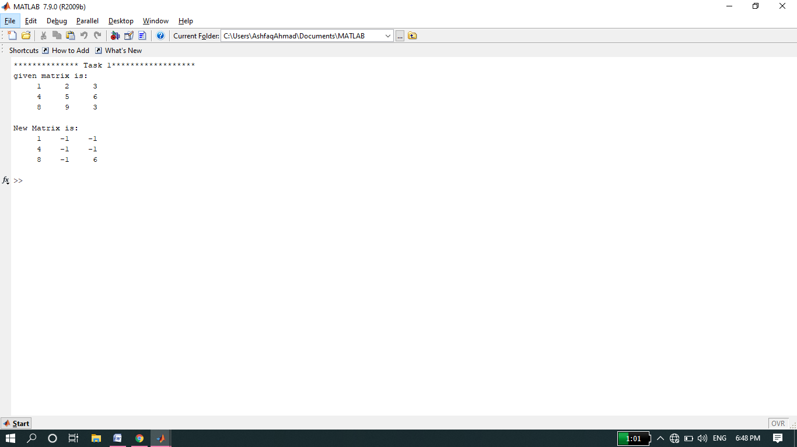

**-------------------------TASK 02--------------------------**

* Generate two 2500 sampled random discrete time signals (1 dimensional) using rand() function i.e. rand(1, 2500). Write a program to add the two such random signals together using simple vector addition.

**Source code:**

a=rand(1250);

b=rand(1250);

c=a+b;

disp(c);

**Output:**

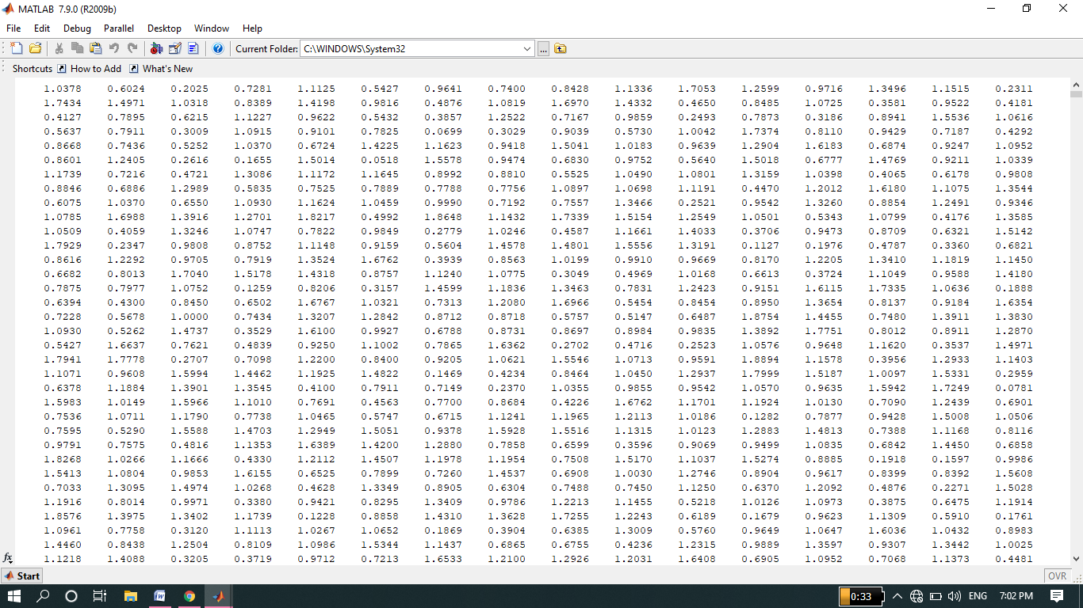

**-------------------------TASK 03--------------------------**

* Using colon notation, generate the following sequence:

-65.25, -57.75, -50.25. . . . . . . . . . ., 54.75,62.25, 69.75

**Source code:**

disp('the random vlaues from -65.25 to 69.75 are having a gap of 7.5: ');

a=(-65.25:7.5:69.75);

disp(a);

**Output:**

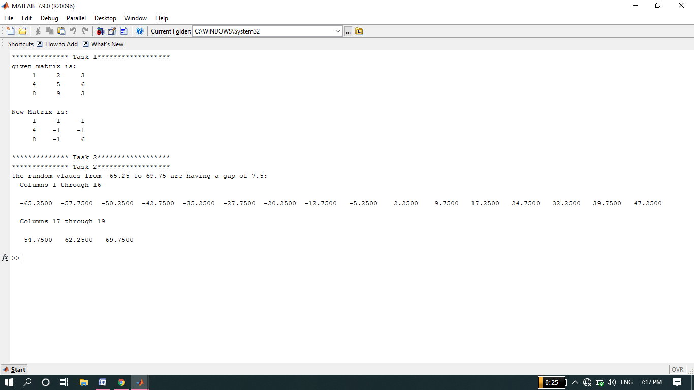

**-------------------------TASK 04--------------------------**

**Source Code:**

a=[-12,34,61,-9;65,78,90,12; 14,78,45,12; 60,25,3,8];

b=[34,67,8,9; 12,-91,12,9; 89,-8,0,2; 16,9,23,67];

c=a+b;

disp('1) sum');

disp('c= ');

disp(c);

d=a-b;

disp('2) subtraction');

disp('d= ');

disp(d);

E=a*b;

disp('3) Multiplication');

disp('E=');

disp(E);

F=a/b;

disp('4) Division');

disp('F=');

disp(F);

G=a.^b;

disp('5) Power');

disp('G=');

disp(G);

h=sin(a);

i=sqrt(b);

disp('6) sin of A matrix and sqrt of B matrix and its multiplication');

disp('h=');

disp(h);

disp('i=');

disp(i);

j=h*i;

disp('j= ');

disp(j);

**Output:**

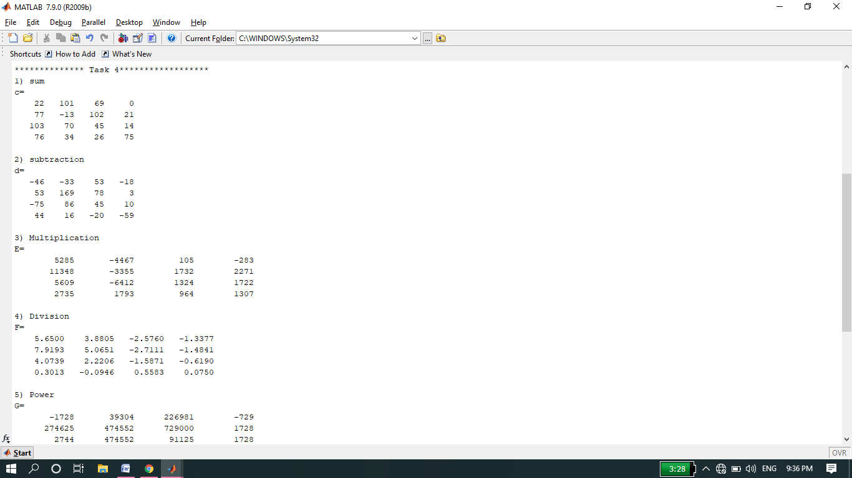

**-------------------------TASK 05--------------------------**

**Source code:**

A=[3 7 -4 12;9 10 2 7;-56 13 8 11;15 5 4 1]

disp('1) 4x3 array B from 4x4 array A by deleting ist coloumn');

B=A;

B(:,1)=[]

disp('2) 3x4 array C from 4x4 array A by deleting ist row');

C=A;

C(1,:)=[]

disp('3) 2x3 array C from 4x4 array A by delting last two rows and ist column');

C=A;

C(3:4,:)=[];

C(:,1)=[]

**Output:**

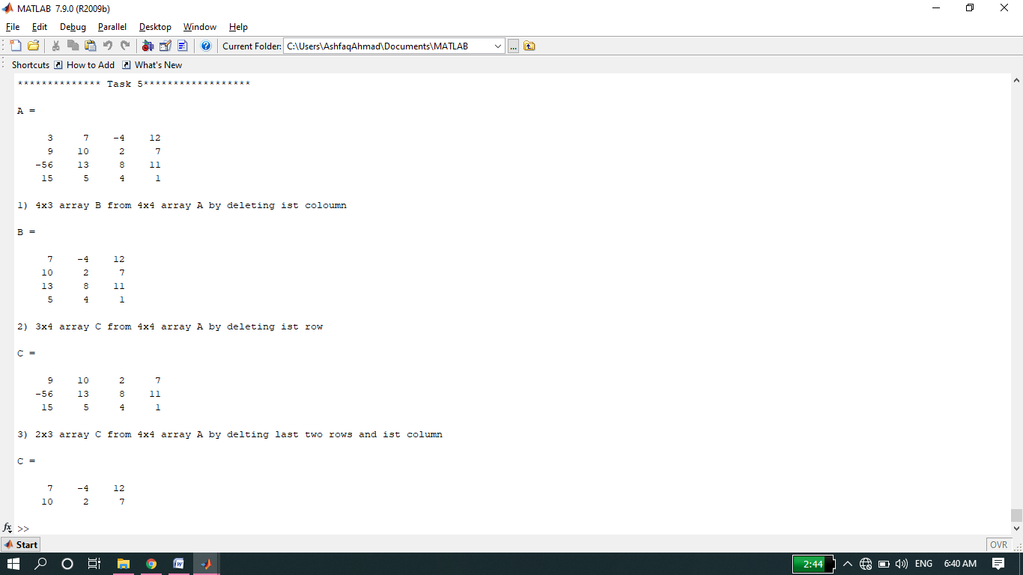

**-------------------------TASK 06--------------------------**

* Test working of round, fix, ceil, and floor Functions.

**Source code:**

f = [-.5 .1 .5]

disp('1)function of round')

round(f)

disp('2)function of fix')

fix(f)

disp('3)function of ceil')

ceil(f)

disp('4)function of floor')

floor(f)

**Output:**

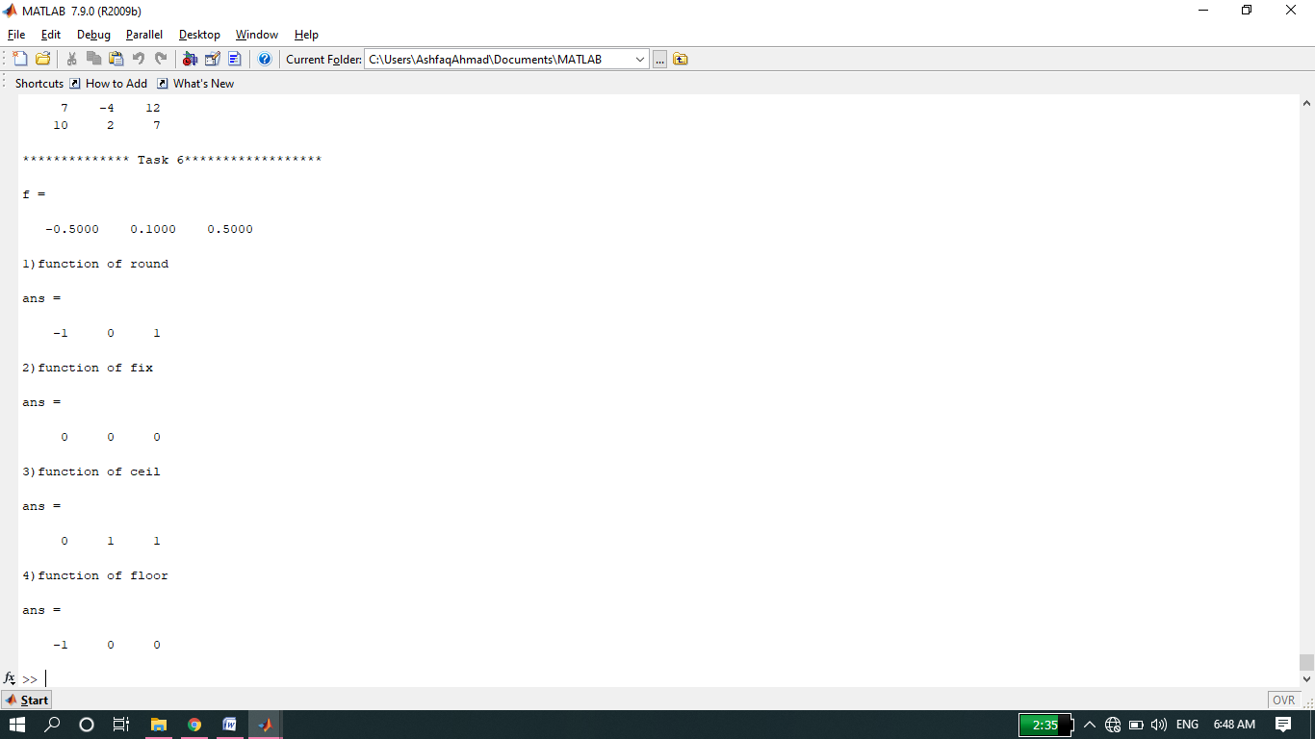

**-------------------------TASK 07--------------------------**

* Coloum-wise and row-wise summation using sum function, length and size of a Matrix.

**Source code:**

A=[-3 5;4 8]

disp('1)Coloumn-wise sum of all elements of Matrix A using sum function');

coloumnsum=sum(A,1)

disp('2)Row-wise sum of all elements of Matrix A using sum function');

rowsum=sum(A,2)

disp('3)length ofmatrix A is:');

length=length(A)

disp('4) size of matrix A is:');

Size=size(A)

**Output:**

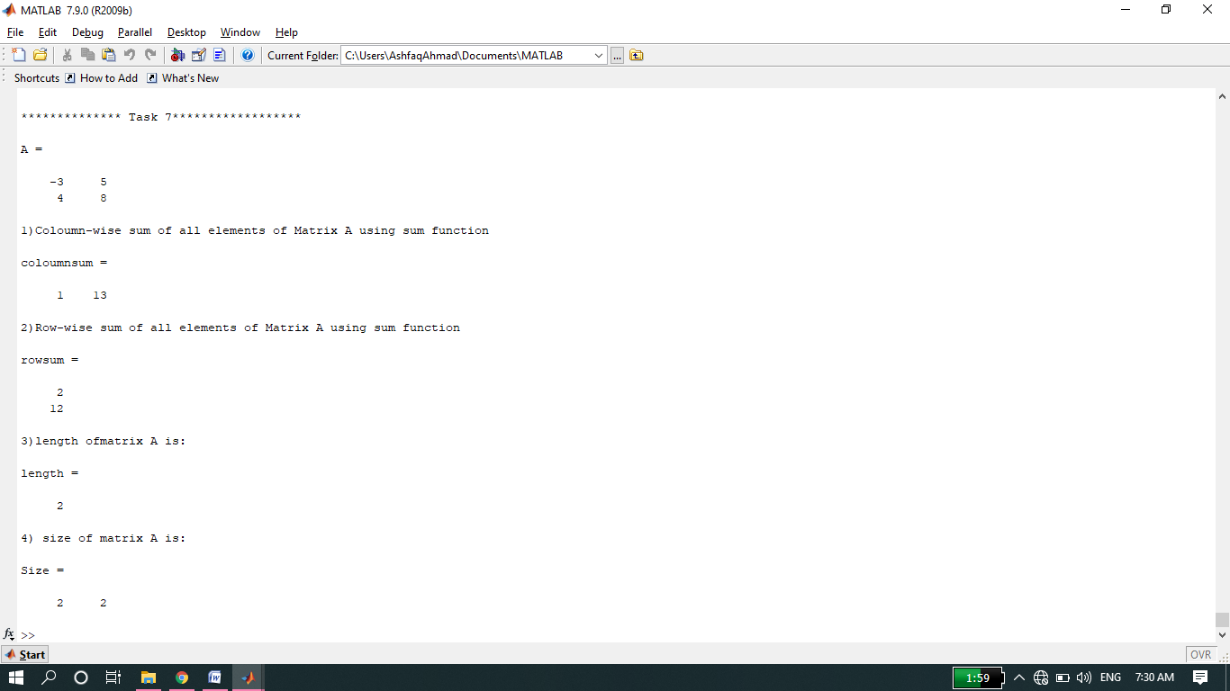

**-------------------------TASK 08--------------------------**

* Updating and deleting last row and last column using “end” command.

**Source code:**

A=[3 23 34 12 34 5 56 23; 12 34 34 32 23 23 45 1;67 23 2 4 4 5 6 456;

67 67 45 67 78 7 8 5;6 35 5 3 5 56 7 8]

disp('1)update the last coloumn of Matrix A using End Command');

B=A;

B(:,end)=[1 2 3 4 5]

disp('2)Delete the last coloumn of Matrix A using End Command');

B(:,end)=[]

disp('3)update the last row of Matrix A using End Command');

A(end,:)=[1 2 3 4 5 6 7 8]

disp('4)Delete the last row of Matrix A using End Command');

A(end,:)=[]

**Output:**

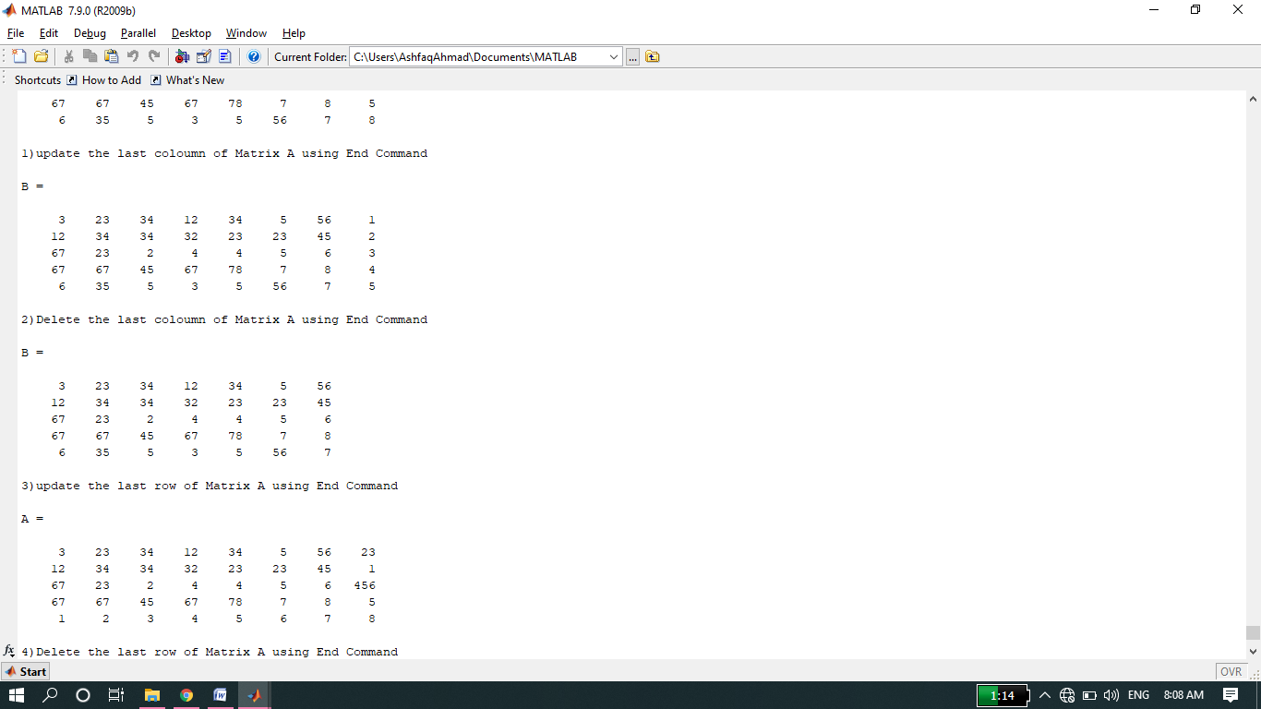

**-------------------------TASK 09--------------------------**

A= 3 23 34 12 34 5 56 23;

12 34 34 32 23 23 45 1;

67 23 2 4 4 5 6 456;

67 67 45 67 78 7 8 5;

6 35 5 3 5 56 7 8

1. A(3,end)

* It display the element at position 3X8 in Matrix A I,e 456.

1. A(:)

* It displays all columns of matrix A in a single columns.

1. A(:,end)

* It display the last column of the matrix A.

1. Y=linspace(20,100)

* It generate linearly spaced vector having 100 integers between 20 and 100.it is similar to colon operator “:”.

1. Y=linspace(20,100,50)

* It will generate linearly spaced vector having 50 terms between 20 and 100.

**-------------------------TASK 10--------------------------**

* Finding values of unknown in a given system of equations.

X+2y+3z=1

4x+5y+6z=2

7x+8y+0.z=1

Formula is x=A’b (inversion method).

**Source code:**

clc

clear all

close all

disp('we will make the matrix from the system of equations')

A=[1,2,3;4,5,6;7,8,0]

b=[1;2;1]

disp('inverse of a matrix A: ')

A=(inv(A))

disp('now using inversion method to find the value of veriables')

w=A*b;

x=w(1,1)

y=w(2,1)

z=w(3,1)

**Output:**

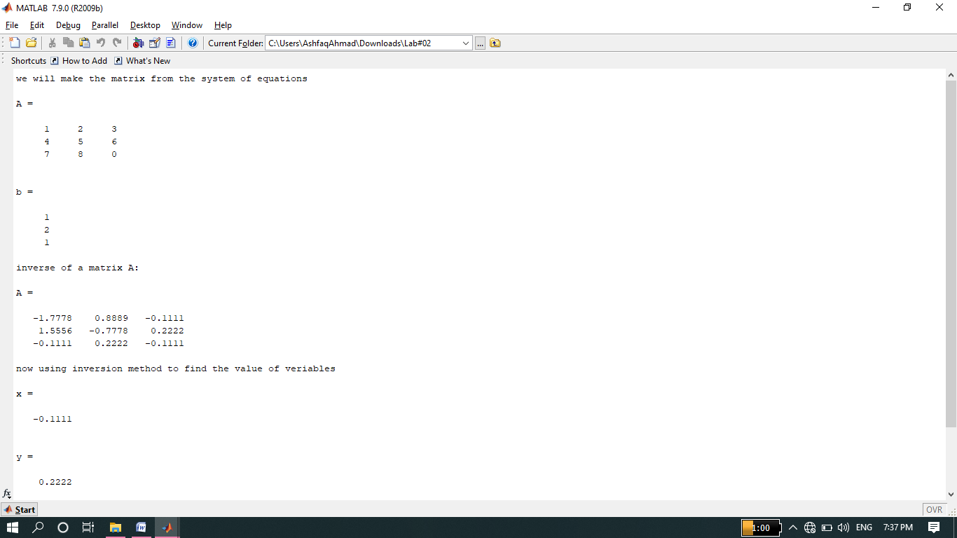

**-------------------------TASK 11--------------------------**

**Source code:**

clc

clear all

close all

disp('In task 11 taking matrix A and b from the user in run time:')

R=input('Enter the size of matrix A and : ');

for i=1:R

for j=1:R

A(i,j)=input('Enter the matrix elements: ');

end

end

disp('Matrix A= ')

disp(A);

for k=1:R

b(k,1)=input('Now enter the elelments of b matrix: ');

end

disp('Matrix b= ')

disp(b);

disp('inverse of a matrix A: ')

A=(inv(A))

disp('now using inversion method to find the value of veriables X,Y and Z')

w=A*b;

x=w(1,1)

y=w(2,1)

z=w(3,1)

**Output:**

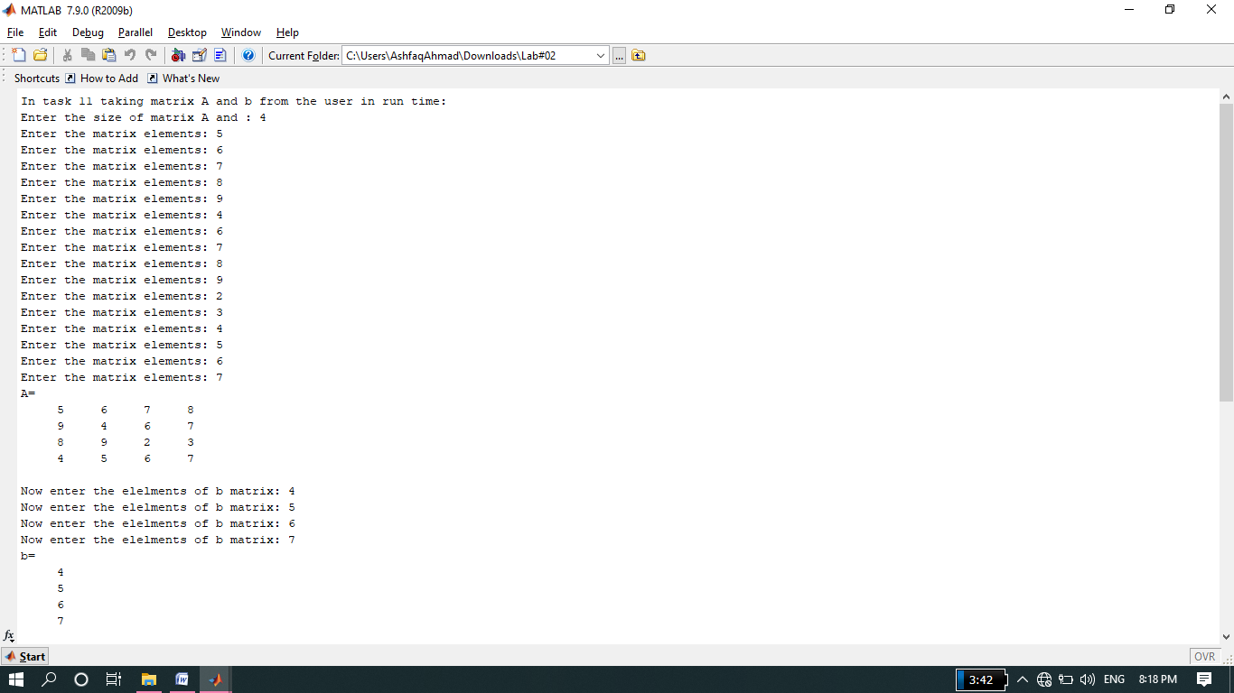

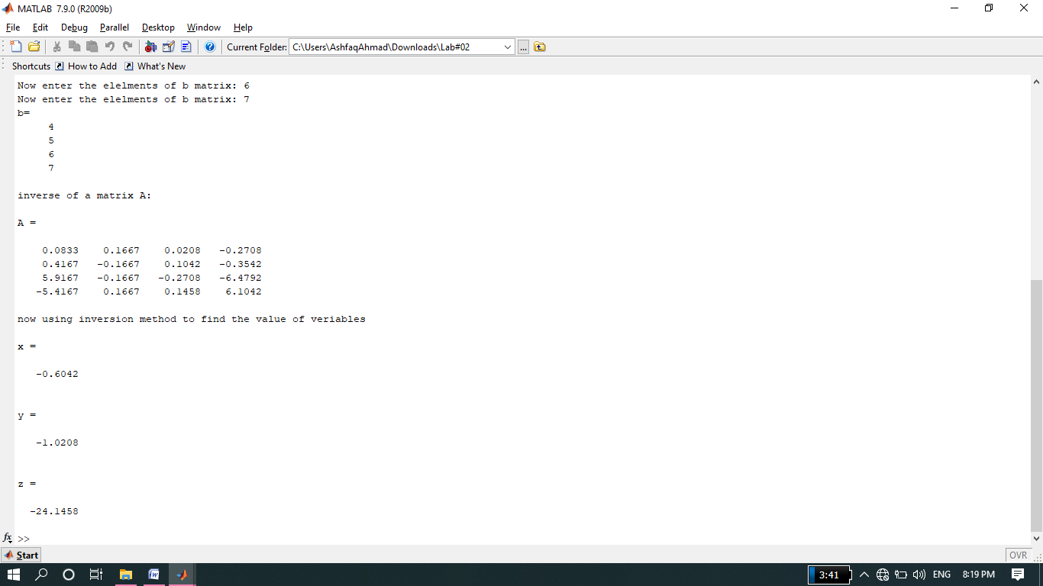

Prepared By Ashfaq Ahmad

THE END